**NAN MUDHALVAN PROJECT**

**COLLEGE NAME : ALAGAPPA GOVERMENT ARTS COLLEGE**

**DEPARTMENT : B.COM**

**PLACE : KARAIKUDI**

**PROJECT NAME : TECHPRO SOLUTIONS**

**OUR TEAM MEMBERS**

1. **AL. SHRUTHI**
2. **M.STENY IDHAYA**
3. **R. SUBA SREE**
4. **U.SUBAJANANI**

**PROJECT ECT REPORT TEMPLATE**

**1 Introduction**

* 1. **0verview**

**A Brief description about your project**

* 1. **Purpose**

**The use of this project what can be achieved using this project**

**2 Problem definition and design thinking**

**2.1 Empathy map**

**Paste the empathy map screenshot**

* 1. **ideation and brainstorming map**

**Paste the brainstorming map screenshot**

1. **Results**

**Final findings (output) of the project along with screenshots**

1. **Advantages and disadvantages**

**List of advantages and disadvantages of the proposed solution**

1. **Applications**

**The areas where this solution can be applied**

**6 Conclusion**

**Conclusion summarizing the entire work and finding**

**7 Future scope**

**Enhancements that can be made in the future**

**8 Appendix**

**A. Source code**

**Attach the code for the solution built**

**Project Report**

1. **Introduction** 
   1. **Overview**

**Tech pro solutions is our project about a web design company and digital marketing agency with unmatched capabilities and diverse background of building strategic and z oho books helps our project to manage sales and handling invoicing**

* 1. **Purpose**

**We combine cutting edge technologies with strategic expertise to help customers meet their business needs.**

1. **Problem definition and design thinking**
   1. **Empathy map**

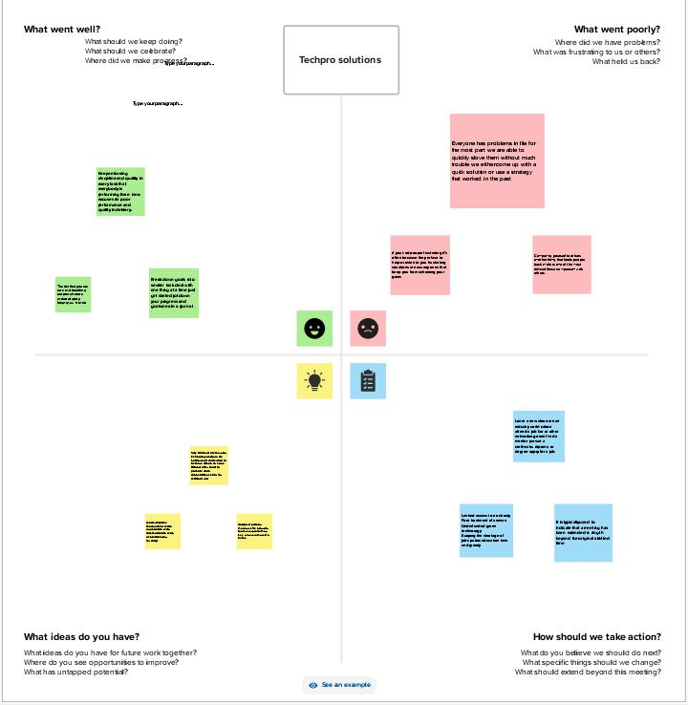

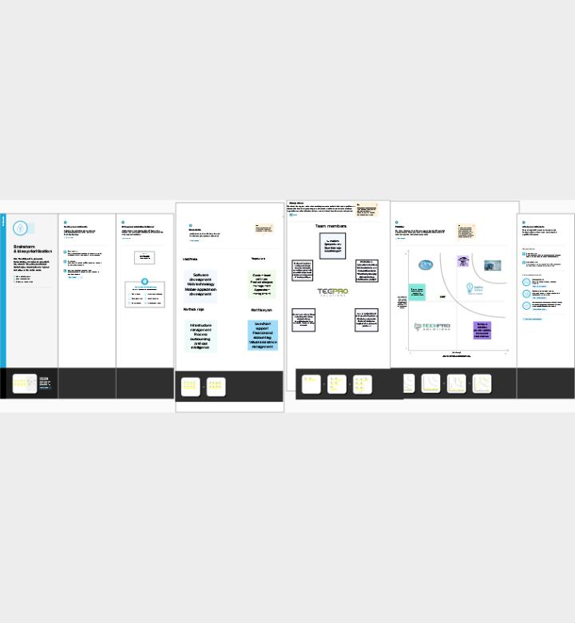**2.2 Brainstorming map**

1. **Results**

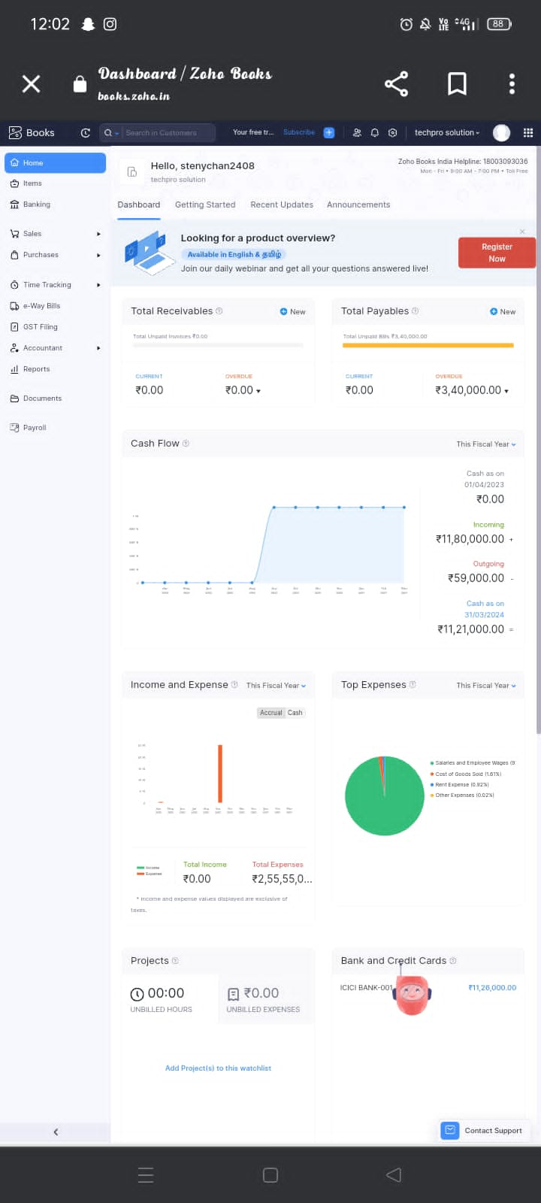

1. **Advantages and disadvantages**

**Advantages**

* **Tech pro solutions provides a full range of services that are essential to the success of your business.**
* **Provide technology solutions and custom software development for business of all sizes .**
* **Quality professional services, tech pro can build, design and implement the most advanced software for your organization .**
* **Software development**
* **Web technology**
* **Mobile application development**

**Disadvantages**

* **A great example of tech’s prevalence in the modern day workplace is in remote work . vedio platforms like zoom and communication channels like slack make it easier than ever for workers to connect with one another from anywhere in the world. But is something also lost in this shift to hybrid or work from home formats?**
* **A Gallup poll suggests that there is much at risk indeed. Remote workers reported feeling less valued or recognized while working remotely they also feel less like someone at work cares about them and that their opinions matter less . these are major blows that can lead to a lack of investment in the company’s mission and culture , which could have larger negative implications for your business over time.**

**5 . Application  
 We provide end to end solution for all your business needs including web applications , e Commerce websites, mobile apps, offshore, development and custom software development.  
  
  
6. Conclusion  
 We combine cutting edge technologies with strategic to help customers meet their business needs. We utilize the latest technology to provide sophisticated and secure IT solutions using an effective delivery model to ensure flexibility and agility. Our specialty of operations includes application lifecycle management . our high performance business strategy builds on our expertise in consulting, technology and outsourcing to help clients perform at the highest levels so that they can create sustainable value for their customers and shareholders. Using our industry knowledge ,service offering expertise and technological capabilities , we identify new business and technology trends and develop solutions to help clients across the globe.**